Mini Project: To-Do App (JavaScript) — Step-by-Step with Code
This is a real beginner → intermediate level project that combines:
- DOM manipulation
- Arrays
- Events
- Local storage (optional advanced)

🎯 Features
- ➕ Add task
- ❌ Delete task
- ✅ Mark as completed
- 💾 Save tasks (localStorage)

🧱 Project Structure
todo-app/
├── index.html
├── style.css
└── script.js

🧩 How It Works (Architecture)

1️⃣ HTML (index.html)
<!DOCTYPE html>
<html>
<head>
<title>To-Do App</title>
<link rel="stylesheet" href="style.css">
</head>
<body>

<h2>📝 To-Do App</h2>

<input type="text" id="taskInput" placeholder="Enter task">
<button onclick="addTask()">Add</button>

<ul id="taskList"></ul>

<script src="script.js"></script>
</body>
</html>

2️⃣ CSS (style.css)
body {
font-family: Arial;
text-align: center;
}

ul {
list-style: none;
}

li {
margin: 10px;
}

.completed {
text-decoration: line-through;
color: gray;
}

3️⃣ JavaScript (script.js)

Step 1: Store Tasks
let tasks = [];

Step 2: Add Task
function addTask() {

let input = document.getElementById("taskInput");
let taskText = input.value;

if(taskText === "") return;

tasks.push(taskText);

input.value = "";

renderTasks();
}

Step 3: Render Tasks
function renderTasks() {

let list = document.getElementById("taskList");
list.innerHTML = "";

for(let i = 0; i < tasks.length; i++){

let li = document.createElement("li");

li.innerHTML = `
${tasks[i]}
<button onclick="deleteTask(${i})">❌</button>
`;

list.appendChild(li);
}
}

Step 4: Delete Task
function deleteTask(index) {

tasks.splice(index, 1);

renderTasks();
}

Step 5: Mark as Completed
function toggleComplete(event) {
event.target.classList.toggle("completed");
}
👉 Update render:
li.onclick = toggleComplete;

💾 Step 6 (Advanced): Local Storage
Save tasks:
localStorage.setItem("tasks", JSON.stringify(tasks));
Load tasks:
let saved = localStorage.getItem("tasks");

if(saved){
tasks = JSON.parse(saved);
renderTasks();
}
👉 Add this inside script:
window.onload = function(){
let saved = localStorage.getItem("tasks");
if(saved){
tasks = JSON.parse(saved);
renderTasks();
}
}

🔄 Data Flow

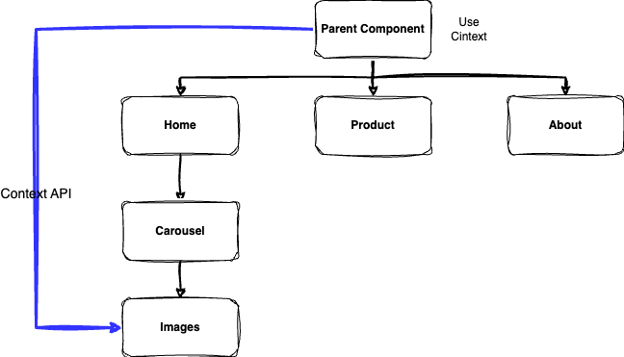

🚀 Final Complete JS Code
let tasks = [];

window.onload = function(){
let saved = localStorage.getItem("tasks");
if(saved){
tasks = JSON.parse(saved);
renderTasks();
}
}

function addTask() {

let input = document.getElementById("taskInput");
let taskText = input.value;

if(taskText === "") return;

tasks.push(taskText);

localStorage.setItem("tasks", JSON.stringify(tasks));

input.value = "";

renderTasks();
}

function deleteTask(index) {

tasks.splice(index, 1);

localStorage.setItem("tasks", JSON.stringify(tasks));

renderTasks();
}

function renderTasks() {

let list = document.getElementById("taskList");
list.innerHTML = "";

for(let i = 0; i < tasks.length; i++){

let li = document.createElement("li");

li.innerHTML = `
${tasks[i]}
<button onclick="deleteTask(${i})">❌</button>
`;

li.onclick = function(){
li.classList.toggle("completed");
}

list.appendChild(li);
}
}

🎯 What You Learned
Concept | Used
DOM | ✔
Events | ✔
Arrays | ✔
Loops | ✔
Local Storage | ✔
Functions | ✔

